ELECTRONIC SUPPLEMENTARY MATERIAL

Sex-specific endocrine regulation of seasonal aggression in Siberian hamsters

Kathleen M. Munley¹, Jonathan C. Trinidad², and Gregory E. Demas¹

¹Department of Biology and Center for the Integrative Study of Animal Behavior, Indiana University, Bloomington, IN 47405, USA, and ²Department of Chemistry, Indiana University, Bloomington, IN 47405, USA
METHODS
Seasonal phenotypes
Body mass was measured weekly throughout the study, and reproductive tissues (testes for males, ovaries for females) were collected and weighed after 10 weeks of photoperiodic treatment and injections. These two measures were the primary criteria used to classify hamsters as responsive or non-responsive to photoperiodic treatment. For all hamsters in the LD and SD groups, each of the two variables used for classification agreed. LD hamsters had functional reproductive tissues (i.e., males had a paired testes mass between 0.690-0.890 g, females had a paired ovarian mass between 9-24 mg) and displayed no significant change in body mass. By contrast, LD-M and SD hamsters that were responsive to photoperiodic treatment had regressed reproductive tissues [i.e., had a paired testes mass (for males) or a paired ovarian mass (for females) that was > 2 standard deviations below the average mass of LD hamsters] and showed a significant change in body mass [> 4%; percent change in body mass (means ± SEM) – LD-M males: -14.1 ± 1.43%, SD males: -7.43 ± 1.28%, LD-M females: -12.9 ± 2.24%, SD females: -8.09 ± 1.00%].

Behavioural testing
Behavioural trials for the resident-intruder paradigm were performed within the first 3 h of the dark phase. Staged dyads were formed, which were composed of an experimental (i.e., resident) animal and a stimulus animal (i.e., intruder) of approximately the same age and body mass (± 5%) and with different parents from the experimental animal with which they were paired. The intruder was placed into the resident’s home cage, which had not been changed for 7 d prior to behavioural testing to allow the experimental (resident) animal to establish its territory (1, 2), for a period of 5 min. All trials were performed under low red-light illumination, and intruders had small, shaved patches on their dorsa for the purpose of identification. Each intruder was used no more than twice per testing period (e.g., group of behaviour trials conducted in a single day, which was approximately 2-3 h in duration and consisted of 13-15 trials). If an intruder was used twice during a single testing period (n = 5 occurrences), the behaviour trials for which this hamster was used were separated by ≥ 1.5 h. Hamsters used as intruders (males: n = 14, females: n = 14) were housed in pairs with a same-sex sibling and maintained in LDs prior to behavioural testing and throughout the study.
Behavioural interactions were video recorded and scored for aggressive and non-aggressive (i.e., investigation, self-grooming) behaviours by a single observer (K.M.M.) who was blind to the experimental conditions. Measures of aggression, investigation, and grooming were defined according to prior studies on same-sex social behaviour in male and female Siberian hamsters (3, 4). Eight hamsters (males – LD: n = 2, LD-M: n = 2, SD: n = 3; females – LD: n = 1) did not display attacking behaviour during the testing period and were assigned an attack latency of 300 s for the purpose of statistical analysis. For the principal component analyses (PCAs) used to generate a composite ‘aggression score’ (PC_{Agg}) and a composite ‘investigation score’ (PC_{Inv}), the set of variables included in each PCA was evaluated for suitability of factor analysis with the Kaiser-Meyer-Olkin measure of sampling adequacy and Bartlett's test of sphericity (5) using the KMO and cortest.bartlett functions of the psych package in R version 4.1.2 (6, 7). The data that comprised each PCA had a Kaiser-Meyer-Olkin measure of sampling adequacy > 0.500 and a significant p-value (p < 0.05) for Bartlett’s test of sphericity and, thus, were considered appropriate for factor analysis (8, 9) (PC_{Agg} – Kaiser-Meyer-Olkin measure of sampling adequacy = 0.650, Bartlett’s test of sphericity: χ² = 180.613, d.f. = 10, p < 0.001; PC_{Inv} – Kaiser-Meyer-Olkin measure of sampling adequacy = 0.540, Bartlett’s test of sphericity: χ² = 120.840, d.f. = 6, p < 0.001). PCAs were conducted using the prcomp function of the stats package (6), and data were standardized using Z-scores to account for differences in scaling between variables (10).

Tissue collection and processing
Following behavioural testing, hamsters were euthanized with a lethal intraperitoneal injection (0.3 mL) of ketamine (150 mg/kg) and xylazine (30 mg/kg) cocktail in 0.9% saline. Adrenal glands were rapidly extracted (≤ 5 min following euthanasia), placed in polypropylene microtubes (Sarstedt Inc., Nümbrecht, Germany) containing 5 zirconium ceramic beads (1.4 mm diameter; Fisher Scientific, Waltham, WA, USA), flash frozen on dry ice, and stored at -80°C. Whole brains were rapidly extracted (≤ 5 min following euthanasia), flash frozen on crushed dry ice, and stored at -80˚C until sectioning. Following sectioning and microdissection, brain punches were placed in polypropylene microtubes containing 5 zirconium ceramic beads and stored at -80°C. In addition, reproductive tissues (testes for males, ovaries for females) were removed, weighed, and used to classify seasonal phenotypes (see “Seasonal Phenotypes” section above and in the Methods section of the main text).

In vitro measurement of 3β-HSD activity
Tissue homogenate preparation and incubation assay
Prior to the incubation assay, adrenal and brain tissues were homogenized in 200 µL cold sucrose phosphate buffer (100 mM sodium phosphate buffer, 1.5 mM EDTA, and 20% glycerol at pH 7.4) containing four freshly added protease inhibitors [phenylmethylsulfonyl fluoride (1 mM), peptastin A (5 µg/mL), antipain (5 µg/mL), and leupeptin (5 µg/mL)]. Following homogenization, samples were aliquoted into three tubes: 1) a protein sample (10 µL), which was used to measure total protein content (see “Protein Content” section below), 2) a pre-incubation assay sample (adrenals: 7.5 µL, brain: 95 µL), which was used to measure baseline concentrations of progesterone (PROG)-c₂d₂ and androstenedione (AE)-d₂, and 3) a post-incubation assay sample (adrenals: 7.5 µL, brain: 95 µL), which was used to measure post-incubation concentrations of PROG-c₂d₂ and AE-d₂. Protein and pre-incubation assay samples were flash frozen on dry ice and stored at -80°C, and all steps prior to freezing (for protein and pre-incubation assay samples) or incubation (for post-incubation assay samples) were carried out on wet ice. Control samples, which contained all components except for supernatant, were incubated alongside experimental samples and were used to confirm a lack of 3β-HSD enzymatic activity in the absence of adrenal and brain tissue.

Protein content
Total protein content was determined using a commercially available Bradford assay kit (Pierce™ Coomassie Plus Bradford Assay Kit; Thermo Fisher Scientific, Waltham, MA, USA; micro microplate protocol, working range: 1-25 µg/mL). The validity of the assay was determined by comparing Siberian hamster adrenal and brain samples of varying dilutions with a standard curve generated using bovine serum albumin reference standards provided by the kit. Brain samples were diluted 1:40 and adrenal samples were diluted 1:200 or 1:500 in incubation assay buffer (100 mM sodium phosphate buffer, 1.5 mM EDTA, 20% glycerol, 1 mM phenylmethylsulfonyl fluoride, and 5 µg/mL pepstatin A, antipain, and leupeptin at pH 7.4) that was diluted 1:2 with ultrapure water. Samples were run in duplicate per the manufacturer’s instructions using an xMark™ Microplate Absorbance Spectrophotometer (Bio-Rad Laboratories, Hercules, CA, USA), and all samples contained protein concentrations that were within the working range of the assay. Tissue samples from different treatment groups were counterbalanced across six 96-well plates, and adrenal and brain samples from the same individual were run on the same plate. Samples with a coefficient of variability (CV) greater than 20% were re-analysed. Inter-assay and intra-assay CVs were determined using pooled adrenal gland and brain samples from LD hamsters. The inter-assay variability was ≤ 11.23% (adrenals: 11.23%, brain: 9.21%), and the intra-assay variability was ≤ 3.59% (adrenals: 1.52 ± 0.12%, brain: 3.59 ± 0.67%).

Validations of 3β-HSD activity assay
A set of validation studies was performed to optimize the reaction conditions and confirm the efficacy of the 3β-HSD incubation assay. A time course study was conducted to determine the appropriate duration for incubations, in which pooled adrenal and brain supernatants were incubated for 15 min, 30 min, 60 min (1 h), 180 min (3 h), or 360 min (6 h). We determined that PROG-c₂d₂ and AE-d₂ production via 3β-HSD peaked at 3 h for adrenal samples, whereas PROG and AE synthesis peaked at 6 h for brain samples (electronic supplementary material, figure S1); thus, we selected an incubation period of 3 h for adrenal samples and an incubation period of 6 h for brain samples. Furthermore, we determined whether adding abiraterone acetate and fadrozole hydrochloride (pharmacological inhibitors of cytochrome P450c17 and aromatase, respectively) decreased the metabolism of formed PROG-c₂d₂ and AE-d₂. Because PROG and AE synthesis was significantly lower in adrenal and brain samples that did not contain these inhibitors relative to control samples (Welch’s t-tests, p ≤ 0.025 for all comparisons; electronic supplementary material, table S2), abiraterone acetate and fadrozole hydrochloride were included in the incubation assay. Finally, we confirmed that trilostane, a pharmacological inhibitor of 3β-HSD, significantly reduced PROG-c₂d₂ and AE-d₂ production in adrenal and brain samples compared to control samples (Welch’s t-tests, p ≤ 0.031 for all comparisons; electronic supplementary material, figure S2).

Steroid extraction for LC-MS/MS
In addition to isotopically labelled analogues of PROG and AE (PROG-d₉ and AE-d₇), 5 ng of pregnanediol in 20% acetonitrile with 0.1% formic acid was spiked into each sample to mitigate potential stickiness of isotopically labelled and endogenous steroids for plastics and glass used in the steroid extraction procedure. Samples were centrifuged at 16,100 x g for 10 min at 4°C, and supernatant (adrenals: 20 µL, brain: 100 µL) was collected into 16 x 100 mm glass test tubes stored on wet ice. The centrifugation process was repeated after adding 100 µL 100% acetonitrile with 0.1% formic acid to each sample, and 100 µL of the supernatants was transferred to their respective glass test tubes. Samples were then placed in a water bath, dried at 35°C for 60 min using an Evap-O-Rac system (Cole-Parmer, Vernon Hills, IL, USA), and reconstituted in 100 µL 20% methanol with 0.1% formic acid. For steroid extraction, C18 OMIX tips (Agilent Technologies, Santa Clara, CA, USA) were primed with 200 µL 100% acetonitrile with 0.1% formic acid and conditioned with 200 µL water with 0.1% formic acid. 100 µL of each sample was drawn up and passed through the tips 20 times, tips were washed with 35 µL water with 0.1% formic acid, and samples were eluted with 100 µL 100% acetonitrile with 0.1% formic acid and collected into 2 mL amber vials fitted with 250 µL glass vial inserts (Agilent Technologies, Santa Clara, CA, USA). In addition, 10 µL of isotopically labelled steroids, which contained 5 µL of 1 µM PROG-d₉ and 5 µL of 1 µM AE-d₇ in 20% acetonitrile with 0.1% formic acid, was added directly into an amber vial fitted with a glass vial insert. This sample, which represented the empirical expected concentrations of isotopically labelled analogues of PROG and AE, was run alongside tissue samples and was used to track percent recovery for the liquid chromatography-tandem mass spectrometry (LC-MS/MS) protocol. All samples were dried in a CentriVap vacuum concentrator (Labconco, Kansas City, MO, USA), reconstituted in 20 µL 20% acetonitrile with 0.1% formic acid, sealed with crimp top caps (11 mm diameter; Agilent Technologies, Santa Clara, CA, USA), and stored at -20˚C.
LC-MS/MS analysis
For LC-MS/MS analysis, 5 µL of sample was loaded onto an Acclaim PepmapTM C18 RSLC column (75 μm x 25 cm, particle size: 2 μm, pore size: 100 Å; Thermo Fisher Scientific, Waltham, WA, USA), and steroids were separated using an acetonitrile-based gradient (solvent A: 0% acetonitrile with 0.1% formic acid, solvent B: 80% acetonitrile with 0.1% formic acid) at a flow rate of 300 nL/min. The column and precolumn were equilibrated with 5 μL of each solvent prior to injection. A 22 min gradient was performed as follows: 0 to 0.5 min, 15% to 50% solvent B; 0.5 to 16 min, 50% to 100% solvent B; 16 to 22 min, 100% solvent B. Precursor ions were isolated in scheduled time windows corresponding to their expected retention times, and a window of 1.6 Da was used for isolation prior to fragmentation. Steroids were collisionally fragmented using higher-energy collisional dissociation (HCD) mode with an energy of 35 V, and fragment ions were measured in the Orbitrap Fusion Lumos mass spectrometer using a resolution of 120,000 over a mass range of 70-400 Da. For data extraction of fragment ions, a window ± 0.004 Da was used. Prior to quantification, data were processed using a 9-point smooth filter with a baseline window of 102, and each peak was manually inspected to confirm accurate peak detection. PROG-c₂d₂ and AE-d₂ concentrations were calculated using isotopic internal standard quantification, in which the amount of the isotopically labelled analogue for each steroid (PROG-d₉ and AE-d₇, respectively) was multiplied by the ratio of the fragment ion signal for the steroid of interest (i.e., PROG-c₂d₂ or AE-d₂) to the fragment ion signal for their corresponding isotopically labelled analogue (i.e., PROG-d₉ or AE-d₇) (11, 12).

Statistical analyses
Statistical outliers were examined with Grubbs’ Tests using the grubbs.test function of the outliers package (13), and data points that affected the conceptual conclusions of the study were excluded from statistical analysis (stated in the footnotes of the statistical analysis summary tables in the electronic supplementary material). For multivariate analyses, normality was assessed with Royston’s H tests and homogeneity of covariance matrices was assessed with Box’s M tests using the assumptions_manova function of the micompr package (14). For univariate analyses, normality of linear model residuals was assessed with Shapiro-Wilk tests using the shapiro.test function of the stats package (6), and homogeneity of variances was assessed with Levene’s tests using the leveneTest function of the car package (15). Data that exhibited a non-normal distribution were visualized with Cullen and Frey plots using the descdist function of the fitdistrplus package, and the best-fit model was selected on the basis of Akaike Information Criterion (AIC) and Bayesian Information Criterion (BIC) values generated using the gofstat function of the fitdistrplus package (16).
For each model, R² values (for two-way MANOVAs and ANOVAs) and Wald χ² values (for GLMs) were calculated to assess goodness of fit, and R² (for PERMANOVAs), partial η² (for two-way MANOVAs and ANOVAs), and Nagelkerke's pseudo-R² values (for GLMs) were determined to estimate effect size (presented in the main text and electronic supplementary material) (17, 18). For estimations of effect size, 0.04-0.25 indicates a small effect, 0.25-0.64 indicates a moderate effect, and > 0.64 indicates a strong effect (19). Data were analysed using the adonis function of the vegan package (PERMANOVAs) (20), the lm and manova functions of the stats package (ANOVAs and MANOVAs, respectively) (6), the glht function of the multcomp package (Tukey’s HSD post-hoc tests) (21), the dunn.test function of the dunn.test package (Dunn’s post-hoc tests) (22), the summ function of the jtools package (Wald χ² and Nagelkerke's pseudo-R² values) (23), and the etasq function of the heplots package (partial η² values) (24).

TABLES

Table S1. Principal component loading values and eigenvalues for variables that were used to generate composite aggression and investigation scores via principal component analysis.

Variables | PC_{Agg} | Variables | PC_{Inv}
Number of Attacks | 0.506 | NTN Frequency | 0.532
Attack Duration | 0.426 | NTN Duration | 0.492
Number of Chases | 0.468 | AGI Frequency | 0.539
Chase Duration | 0.460 | AGI Duration | 0.429
Latency to First Attack | -0.363
Eigenvalues | 3.160 |  | 2.543

Composite aggression and investigation scores (PC_{Agg} and PC_{Inv}, respectively) were used to determine the effects of melatonin and photoperiodic treatment, sex, and the interaction between treatment and sex on aggressive and investigative social behaviours. PC_{Agg} accounted for 63.2% of the total variance, and PC_{Inv} accounted for 63.6% of the total variance. Bold values indicate variables that loaded strongly (< -0.3 or > 0.3) onto a given principal component. Abbreviations: AGI, anogenital investigation; NTN, nose-to-nose investigation.

Table S2. MS/MS transitions for internal standards and endogenous and isotopically labelled steroid hormones in Siberian hamster adrenal and brain tissue.

Steroid | Retention Time (min) | Mass-to-Charge Ratio (m/z)
 |  | Precursor | Fragment
Dehydroepiandrosterone-d₂ | 16.0 | 291.2 | 255.208
Androstenedione | 16.1 | 287.2 | 97.065, 109.065
Androstenedione-d₂ | 16.1 | 289.2 | 97.065, 109.065
Androstenedione-d₇ | 16.1 | 294.2 | 100.084, 113.090
Pregnenolone-c₂d₂ | 20.9 | 321.3 | 285.246, 303.257
Progesterone | 21.2 | 315.2 | 97.065, 109.065
Progesterone-c₂d₂ | 21.2 | 319.2 | 97.065, 109.065
Progesterone-d₉ | 21.2 | 324.2 | 100.084, 113.090

Retention times and mass-to-charge ratios of precursor and fragment ions are shown for each internal standard and endogenous and isotopically labelled steroid hormone. Steroids were fragmented using high collision energy dissociation (HCD) fragmentation, and fragment ions were measured using an Easy NanoLC 1200 HPLC coupled to an Orbitrap Fusion Lumos mass spectrometer (see Section H of Methods).
Table S3. Accuracy and precision measurements of internal standards in Siberian hamster tissue for liquid chromatography-tandem mass spectrometry (LC-MS/MS) analysis.

Isotopic Steroid | Empirical Expected  Inter-assay %CV  Intra-assay %CV  % Recovery | Adrenal Glands  Inter-assay %CV  Intra-assay %CV  % Recovery | Brain  Inter-assay %CV  Intra-assay %CV  % Recovery
Progesterone-d₉ | NA  NA  100 | 10.48  6.213 ± 2.030  23.16 ± 5.552 | 12.72  8.073 ± 0.798  4.791 ± 0.573
Androstenedione-d₇ | NA  NA  100 | 11.68  6.119 ± 1.866  38.84 ± 5.199 | 12.42  5.215 ± 2.444  21.73 ± 2.751

Coefficients of variability (CV) were determined using pooled adrenal and hypothalamic (brain) tissue samples, and samples were analysed either across batches (for inter-assay %CV calculations; adrenals: n = 3, brain: n = 3) or within the same batch (for intra-assay %CV calculations, presented as means ± SEM; adrenals: n = 7-8, brain: n = 6). Percent recoveries are presented as means ± SEM (adrenals: n = 16, brain: n = 14) and were calculated relative to the empirical expected sample, which contained 50 nM androstenedione-d₇ and 50 nM progesterone-d₉ in 20% acetonitrile with 0.1% formic acid. The empirical expected sample was run alongside tissue samples during LC-MS/MS analysis.

Table S4. Precision measurements for 3β-hydroxysteroid dehydrogenase/∆5-∆4 isomerase (3β-HSD) enzymatic activity assay in Siberian hamster adrenal and brain tissue.

Measurement | Adrenal Glands  Inter-assay %CV  Intra-assay %CV | Brain  Inter-assay %CV  Intra-assay %CV
3β-HSD Activity, PROG Synthesis  (nmol PROG-c₂d₂/mg protein) | 12.70  3.531 ± 1.053 | 11.03  7.902 ± 0.696
3β-HSD Activity, AE Synthesis  (nmol AE-d₂/mg protein) | 15.62  4.821 ± 1.102 | 15.97  5.694 ± 0.583

Coefficients of variability (CV) were determined using pooled adrenal and hypothalamic (brain) tissue samples, and samples were analysed either across batches (for inter-assay %CV calculations; adrenals: n = 3, brain: n = 3) or within the same batch (for intra-assay %CV calculations, presented as means ± SEM; adrenals: n = 4, brain: n = 4-6). Abbreviations: AE, androstenedione; PROG, progesterone.

Table S5. Timed melatonin injections and short-day photoperiods reduced body and reproductive tissue mass in male and female hamsters.

 | Males |  |  | Females |  |  | F- or H-Statistic | df | p
 | LD | LD-M | SD | LD | LD-M | SD
Percent Change in Body Mass | -4.03 ± 0.99ª | -14.1 ± 1.43^{b} | -7.43 ± 1.28^{b} | -2.14 ± 5.29ª | -12.9 ± 2.24^{b} | -8.09 ± 1.00^{a,b} | 4.180 | 5,38 | 0.004
Paired Testes Mass (g) | 0.77 ± 0.03ª | 0.26 ± 0.04^{b} | 0.39 ± 0.09^{b} | --- | --- | --- | 21.41 | 2,18 | <0.001
Paired Ovarian Mass (mg) | --- | --- | --- | 15.3 ± 2.06ª | 10.5 ± 1.73^{b} | 6.20 ± 1.88^{b} | 4.288 | 2,16 | 0.032

Means ± SEM (males – LD: n = 6, LD-M: n = 8, SD: n = 7-8; females – LD: n = 6, LD-M: n = 8, SD: n = 5-8) of percent change in body mass, paired testes mass, and paired ovarian mass in long-day hamsters (LD), LD hamsters administered timed melatonin injections (LD-M), and short-day hamsters (SD) following 10 weeks of treatment. Significant p-values are shown in bold, and different letters indicate a significant difference between treatment groups within each sex (p < 0.05; percent change in body mass: two-way ANOVA with Tukey’s HSD post-hoc tests; paired testes mass and paired ovarian mass: one-way ANOVAs with Tukey’s HSD post-hoc tests). Outliers excluded from statistical analysis: one SD male for paired testes mass and two SD females for paired ovarian mass.

Table S6. Summary of multivariate statistical analyses performed to examine the effects of melatonin and photoperiodic treatment, sex, and the interaction between treatment and sex on social behaviour in male and female hamsters.
 | Statistical Test | Dependent Variables | Factors | F | df | R² | p | *
Aggression | PERMANOVA | Number of Attacks | Treatment | 4.928 | 1,42 | 0.105 | 0.026 | *
 |  | Attack Duration | Sex | 1.044 | 1,42 | 0.024 | 0.306 | NS
 |  | Latency to First Attack | Treatment*Sex | 3.044 | 2,41 | 0.129 | 0.056 | #
 |  | Number of Chases
 |  | Chase Duration
 |  | AGG Frequency
 |  | AGG Duration
 |  | AGG Score
 |  | PC_{Agg}
Investigation | PERMANOVA | NTN Frequency | Treatment | 0.294 | 1,42 | 0.007 | 0.720 | NS
 |  | NTN Duration | Sex | 0.893 | 1,42 | 0.021 | 0.393 | NS
 |  | AGI Frequency | Treatment*Sex | 0.585 | 2,41 | 0.028 | 0.631 | NS
 |  | AGI Duration
 |  | INV Frequency
 |  | INV Duration
 |  | PC_{Inv}
Grooming | PERMANOVA | GR Frequency | Treatment | 0.379 | 1,42 | 0.009 | 0.546 | NS
 |  | GR Duration | Sex | 1.277 | 1,42 | 0.030 | 0.271 | NS
 |  |  | Treatment*Sex | 0.820 | 2,41 | 0.038 | 0.478 | NS

Permutational multivariate analyses of variance (PERMANOVAs) were used to assess the effects of melatonin and photoperiodic treatment, sex, and the interaction between treatment and sex on aggressive, investigative, and self-grooming behaviours in male and female hamsters (males – LD: n = 5-6, LD-M: n = 8, SD: n = 8; females – LD: n = 5-6, LD-M: n = 7-8, SD: n = 8). F-statistics (F), degrees of freedom (df), estimations of effect size (R²), p-values (p), and statistical significance (*) for each analysis are shown. For tests that either showed a significant effect (p < 0.05, in bold) or trended towards a significant effect (p < 0.10, in bold and italics) of treatment, sex, and/or the interaction between treatment and sex, univariate analyses of variance [two-way analyses of variance (ANOVAs) or generalized linear models (GLMs)] and post-hoc testing (Tukey’s HSD tests for two-way ANOVAs or Dunn’s tests for GLMs) were conducted to examine pairwise comparisons. Abbreviations: AGG, aggression; AGI, anogenital investigation; GR, grooming; INV, investigation; NTN, nose-to-nose investigation; PC_{Agg}, composite aggression score; PC_{Inv}, composite investigation score. Symbols: NS (not significant, p > 0.10), #p < 0.10, *p < 0.05. Outliers excluded from statistical analysis: one LD male and one LD female for number of attacks, one LD male and one LD-M female for attack duration, one LD male and one LD female for AGG frequency, one LD male and one LD-M female for AGG duration, one LD female for AGG score, and one LD male for PC_{Agg}.

Table S7. Summary of univariate statistical analyses performed to examine the effects of melatonin and photoperiodic treatment, sex, and the interaction between treatment and sex on aggressive behaviour in male and female hamsters.
 | Statistical Test and Family | Coefficients | Estimate ± SE | t or z | p | *
Number of Attacks | GLM, Poisson | Treatment | 0.504 ± 0.109 | 4.623 | <0.001 | ***
 | (Log link function) | Sex | 0.181 ± 0.501 | 0.362 | 0.718 | NS
 |  | Treatment*Sex | 0.047 ± 0.143 | 0.329 | 0.742 | NS
Attack Duration | Two-Way ANOVA | Treatment | 10.21 ± 5.418 | 1.885 | 0.067 | #
 |  | Sex | 14.57 ± 21.11 | 0.604 | 0.549 | NS
 |  | Treatment*Sex | -6.100 ± 7.489 | -0.815 | 0.420 | NS
Latency to First Attack | Two-Way ANOVA | Treatment | -21.83 ± 36.86 | -0.592 | 0.259 | NS
 |  | Sex | -0.005 ± 117.6 | 0.000 | 0.618 | NS
 |  | Treatment*Sex | 174.8 ± 83.16 | 2.101 | 0.026 | *
Number of Chases | GLM, Poisson | Treatment | -1.616 ± 1.193 | -1.354 | 0.176 | NS
 | (Log link function) | Sex | 0.073 ± 0.271 | 0.269 | 0.788 | NS
 |  | Treatment*Sex | 0.686 ± 0.353 | 1.941 | 0.052 | #
Chase Duration | GLM, Binomial | Treatment | 1.568 ± 2.993 | 0.524 | 0.600 | NS
 | (Logit link function) | Sex | -0.086 ± 0.901 | -0.096 | 0.924 | NS
 |  | Treatment*Sex | 0.682 ± 0.704 | 0.969 | 0.333 | NS
AGG Frequency | GLM, Poisson | Treatment | 0.439 ± 0.101 | 4.356 | <0.001 | ***
 | (Log link function) | Sex | -0.238 ± 0.468 | -0.509 | 0.611 | NS
 |  | Treatment*Sex | 0.178 ± 0.134 | 1.329 | 0.184 | NS
AGG Duration | Two-Way ANOVA | Treatment | 10.23 ± 5.642 | 1.813 | 0.078 | #
 |  | Sex | 12.70 ± 25.10 | 0.506 | 0.616 | NS
 |  | Treatment*Sex | -5.370 ± 7.797 | -0.689 | 0.495 | NS
AGG Score | GLM, Poisson | Treatment | 0.310 ± 0.088 | 3.516 | <0.001 | ***
 | (Log link function) | Sex | -0.406 ± 0.436 | -0.931 | 0.352 | NS
 |  | Treatment*Sex | 0.146 ± 0.127 | 1.146 | 0.252 | NS
PC_{Agg} | Two-Way ANOVA | Treatment | -1.431 ± 0.785 | 3.327 | 0.092 | #
 |  | Sex | -0.149 ± 2.200 | 1.671 | 0.204 | NS
 |  | Treatment*Sex | 0.270 ± 0.684 | 0.155 | 0.696 | NS

Two-way analyses of variance (ANOVAs) and generalized linear models (GLMs) were used to examine the effects of melatonin and photoperiodic treatment, sex, and the interaction between treatment and sex on aggression in male and female hamsters (males – LD: n = 5-6, LD-M: n = 8, SD: n = 8; females – LD: n = 5-6, LD-M: n = 7-8, SD: n = 8). Coefficient estimates ± standard error (SE), t-statistics (t, for two-way ANOVAs), z-statistics (z, for GLMs), p-values (p), and statistical significance (*) for each model are shown. Boldface indicates p < 0.05, whereas boldface and italics indicate p < 0.10. Test statistics (F-statistic for two-way ANOVAs and Wald χ² for GLMs) and estimations of effect size (R² values for two-way ANOVAs and Nagelkerke's pseudo-R² values for GLMs) for each model are provided in the Results section of the main text. Abbreviations: AGG, aggression; PC_{Agg}, composite aggression score. Symbols: NS (not significant, p > 0.10), #p < 0.10, *p < 0.05, ***p < 0.001. Outliers excluded from statistical analysis: one LD male and one LD female for number of attacks, one LD male and one LD-M female for attack duration, one LD male and one LD female for AGG frequency, one LD male and one LD-M female for AGG duration, one LD female for AGG score, and one LD male for PC_{Agg}.

Table S8. Treatment with timed melatonin injections and short-day photoperiods increased aggressive behaviour in male and female hamsters.

 | Males |  |  | Females
 | LD | LD-M | SD | LD | LD-M | SD
Number of Attacks | 1.800 ± 0.917ª | 10.13 ± 3.786^{b} | 10.13 ± 4.068^{b} | 5.400 ± 2.731ª | 10.00 ± 3.262^{a,b} | 16.75 ± 4.624^{b}
Attack Duration | 3.508 ± 2.190ª | 22.94 ± 8.146^{b} | 25.47 ± 11.58^{b} | 12.10 ± 6.009ª | 10.43 ± 3.278ª | 19.80 ± 3.492ª
Latency to First Attack (s) | 169.8 ± 47.51ª | 144.5 ± 38.87ª | 155.4 ± 44.79ª | 146.3 ± 47.39ª | 48.88 ± 11.58^{b} | 83.13 ± 14.85^{a,b}
Number of Chases | 0.000 ± 0.000ª | 2.375 ± 1.499^{b} | 0.375 ± 0.263^{a,b} | 0.833 ± 0.654ª | 1.375 ± 0.653^{a,b} | 3.375 ± 1.647^{b}
AGG Frequency | 1.800 ± 0.917ª | 12.50 ± 5.227^{b} | 10.50 ± 4.259^{b} | 5.600 ± 2.839ª | 11.38 ± 3.798^{a,b} | 20.13 ± 5.696^{b}
AGG Duration | 3.508 ± 2.190ª | 24.26 ± 8.795^{b} | 25.72 ± 11.70^{b} | 12.32 ± 6.127ª | 11.29 ± 3.894ª | 21.49 ± 3.658ª
AGG Score | 5.833 ± 3.591ª | 11.25 ± 3.432^{b} | 12.13 ± 4.696^{b} | 5.600 ± 2.731ª | 10.63 ± 3.713^{a,b} | 15.13 ± 3.131^{b}

Means ± SEM (males – LD: n = 5-6, LD-M: n = 8, SD: n = 8; females – LD: n = 5-6, LD-M: n = 7-8, SD: n = 8) of number of attacks, attack duration, latency to first attack, number of chases, aggression (AGG) frequency, AGG duration, and AGG score in long-day hamsters (LD), LD hamsters administered timed melatonin injections (LD-M), and short-day hamsters (SD) following 10 weeks of treatment. Different letters indicate a significant difference between treatment groups within each sex (p < 0.05).

Table S9. Summary of multivariate statistical analyses performed to examine the effects of melatonin and photoperiodic treatment, sex, and the interaction between treatment and sex on 3β-hydroxysteroid dehydrogenase/∆5-∆4 isomerase (3β-HSD) activity in the adrenal glands and brain of male and female hamsters.

 | Statistical Test | Dependent Variables | Factors | F | df | η² | p | *
PROG Synthesis | Two-Way MANOVA | Adrenal Glands | Treatment | 0.159 | 3,30 | 0.032 | 0.923 | NS
 |  | AH | Sex | 3.355 | 3,30 | 0.251 | 0.032 | *
 |  | PAG | Treatment*Sex | 0.573 | 3,30 | 0.054 | 0.637 | NS
AE Synthesis | Two-Way MANOVA | Adrenal Glands | Treatment | 1.082 | 3,37 | 0.080 | 0.369 | NS
 |  | AH | Sex | 7.832 | 3,37 | 0.388 | <0.001 | ***
 |  | PAG | Treatment*Sex | 0.080 | 3,37 | 0.006 | 0.971 | NS
AE: PROG Synthesis | Two-Way MANOVA | Adrenal Glands | Treatment | 1.120 | 3,28 | 0.128 | 0.328 | NS
 |  | AH | Sex | 2.945 | 3,28 | 0.183 | 0.050 | #
 |  | PAG | Treatment*Sex | 0.798 | 3,28 | 0.079 | 0.506 | NS

Two-way multivariate analyses of variance (MANOVAs) were used to examine the effects of melatonin and photoperiodic treatment, sex, and the interaction between treatment and sex on adrenal and neural 3β-HSD activity in male and female hamsters (males – LD: n = 4-6, LD-M: n = 6-8, SD: n = 6-8; females – LD: n = 4-6, LD-M: n = 5-8, SD: n = 8). F-statistics (F), degrees of freedom (df), estimations of effect size (partial η²), p-values (p), and statistical significance (*) for each analysis are shown. For tests that either showed a significant effect (p < 0.05, in bold) or trended towards a significant effect (p < 0.10, in bold and italics) of treatment, sex, and/or the interaction between treatment and sex, two-way analyses of variance (ANOVAs) and Tukey’s HSD post-hoc tests were conducted to examine pairwise comparisons. Abbreviations: AE, androstenedione; AH, anterior hypothalamus; PAG, periaqueductal gray; PROG, progesterone. Symbols: NS (not significant, p > 0.10), #p < 0.10, *p < 0.05, ***p < 0.001. Outliers excluded from statistical analysis: one LD female for AE:PROG synthesis in the adrenal glands, two SD males for PROG synthesis in the PAG, one LD-M male for AE synthesis in the PAG, and one LD male, one LD-M male, and one LD-M female for AE:PROG synthesis in the PAG.
Table S10. Summary of univariate statistical analyses performed to examine the effects of melatonin and photoperiodic treatment, sex, and the interaction between treatment and sex on adrenal and neural 3β-hydroxysteroid dehydrogenase/∆5-∆4 isomerase (3β-HSD) activity in male and female hamsters.
 | Tissue or Brain Region | Statistical Test and Family | Coefficients | Estimate ± SE | df | F | p | *
PROG Synthesis | Adrenal Glands | Two-Way ANOVA | Treatment | 43.03 ± 40.89 | 2,38 | 0.255 | 0.776 | NS
 |  |  | Sex | 55.19 ± 184.52 | 1,38 | 8.585 | 0.006 | **
 |  |  | Treatment*Sex | -61.20 ± 57.83 | 2,38 | 1.495 | 0.237 | NS
PROG Synthesis | AH | Two-Way ANOVA | Treatment | 1.328 ± 0.574 | 2,36 | 2.968 | 0.064 | #
 |  |  | Sex | 0.006 ± 0.123 | 1,36 | 1.456 | 0.236 | NS
 |  |  | Treatment*Sex | -0.371 ± 0.178 | 2,36 | 2.839 | 0.072 | #
PROG Synthesis | PAG | Two-Way ANOVA | Treatment | -0.013 ± 0.034 | 2,31 | 0.987 | 0.384 | NS
 |  |  | Sex | 0.206 ± 0.155 | 1,31 | 0.998 | 0.326 | NS
 |  |  | Treatment*Sex | -0.050 ± 0.048 | 2,31 | 0.773 | 0.470 | NS
AE Synthesis | Adrenal Glands | Two-Way ANOVA | Treatment | 437.8 ± 272.5 | 2,38 | 0.607 | 0.550 | NS
 |  |  | Sex | 394.6 ± 1229.7 | 1,38 | 12.62 | 0.001 | **
 |  |  | Treatment*Sex | -482.0 ± 385.4 | 2,38 | 1.297 | 0.285 | NS
AE Synthesis | AH | Two-Way ANOVA | Treatment | -0.629 ± 0.726 | 2,38 | 3.175 | 0.053 | #
 |  |  | Sex | 1.674 ± 3.277 | 1,38 | 0.638 | 0.429 | NS
 |  |  | Treatment*Sex | -0.749 ± 1.027 | 2,38 | 0.567 | 0.572 | NS
AE Synthesis | PAG | Two-Way ANOVA | Treatment | -0.122 ± 0.210 | 2,37 | 0.279 | 0.758 | NS
 |  |  | Sex | -0.028 ± 0.948 | 1,37 | 2.147 | 0.151 | NS
 |  |  | Treatment*Sex | 0.125 ± 0.297 | 2,37 | 0.113 | 0.893 | NS
AE:PROG Synthesis | Adrenal Glands | Two-Way ANOVA | Treatment | -0.158 ± 2.002 | 2,37 | 0.771 | 0.470 | NS
 |  |  | Sex | 11.64 ± 6.389 | 1,37 | 3.337 | 0.076 | #
 |  |  | Treatment*Sex | 1.146 ± 2.901 | 2,37 | 0.130 | 0.879 | NS
AE:PROG Synthesis | AH | Two-Way ANOVA | Treatment | -0.900 ± 2.898 | 2,35 | 0.124 | 0.884 | NS
 |  |  | Sex | -20.26 ± 14.10 | 1,35 | 5.080 | 0.031 | *
 |  |  | Treatment*Sex | 3.959 ± 4.336 | 2,35 | 0.519 | 0.600 | NS
AE:PROG Synthesis | PAG | Two-Way ANOVA | Treatment | -4.981 ± 6.494 | 2,28 | 0.223 | 0.801 | NS
 |  |  | Sex | 37.59 ± 21.54 | 1,28 | 3.059 | 0.091 | #
 |  |  | Treatment*Sex | 4.654 ± 9.583 | 2,28 | 1.465 | 0.248 | NS

Two-way analyses of variance (ANOVAs) were used to examine the effects of melatonin and photoperiodic treatment, sex, and the interaction between treatment and sex on adrenal and neural 3β-HSD activity in male and female hamsters (males – LD: n = 4-6, LD-M: n = 6-8, SD: n = 6-8; females – LD: n = 4-6, LD-M: n = 5-8, SD: n = 8). Coefficient estimates ± standard error (SE), degrees of freedom (df), F-statistics (F), p-values (p), and statistical significance (*) for each model are shown. Boldface indicates p < 0.05, whereas boldface and italics indicate p < 0.10. F-statistics and estimations of effect size (R²) for each model are provided in the Results section of the main text. Abbreviations: AE, androstenedione; AH, anterior hypothalamus; PAG, periaqueductal gray; PROG, progesterone. Symbols: NS (not significant, p > 0.10), #p < 0.10, *p < 0.05, **p < 0.01. Outliers excluded from statistical analysis: one LD female for AE:PROG synthesis in the adrenal glands, two SD males for PROG synthesis in the PAG, one LD-M male for AE synthesis in the PAG, and one LD male, one LD-M male, and one LD-M female for AE:PROG synthesis in the PAG.

Table S11. Treatment with timed melatonin injections and short-day photoperiods had sex-specific effects on the ratio of androstenedione (AE) synthesis to progesterone (PROG) synthesis via 3β-hydroxysteroid dehydrogenase/∆5-∆4 isomerase (3β-HSD) in the adrenal glands and brain of Siberian hamsters.

 | Tissue or Brain Region | Males |  |  | Females
 |  | LD | LD-M | SD | LD | LD-M | SD
AE:PROG Synthesis | Adrenals | 10.32 ± 1.992ª | 12.67 ± 3.948ª | 10.26 ± 2.721ª | 5.141 ± 1.211ª | 10.12 ± 3.045^{b} | 7.781 ± 1.417^{a,b}
AE:PROG Synthesis | AH | 13.77 ± 3.664ª | 16.39 ± 6.531ª | 12.32 ± 4.095ª | 2.681 ± 0.963ª | 6.057 ± 1.337^{a,b} | 8.873 ± 2.739^{b}
AE:PROG Synthesis | PAG | 22.55 ± 10.90ª | 29.43 ± 11.60ª | 19.86 ± 7.247ª | 4.449 ± 1.340ª | 6.708 ± 1.485^{a,b} | 19.76 ± 6.161^{b}

Means ± SEM (males – LD: n = 4-6, LD-M: n = 6-8, SD: n = 8; females – LD: n = 4-6, LD-M: n = 5-8, SD: n = 8) of the ratio of AE:PROG synthesis in the adrenal glands, anterior hypothalamus (AH), and periaqueductal gray (PAG) of long-day hamsters (LD), LD hamsters administered timed melatonin injections (LD-M), and short-day hamsters (SD) following 10 weeks of treatment. Different letters indicate a significant difference between treatment groups within each sex (p < 0.05).

FIGURES

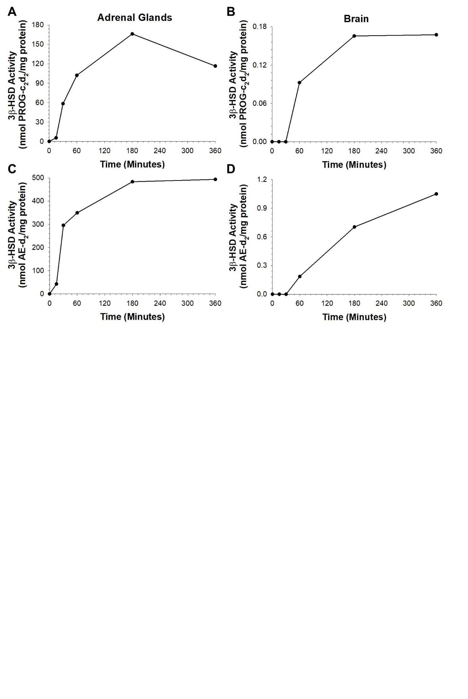

Figure S1. Time course of (A, B) progesterone (PROG) synthesis and (C, D) androstenedione (AE) synthesis by 3β-hydroxysteroid dehydrogenase/∆5-∆4 isomerase (3β-HSD) in the adrenal glands (A, C) and brain (B, D) of Siberian hamsters.

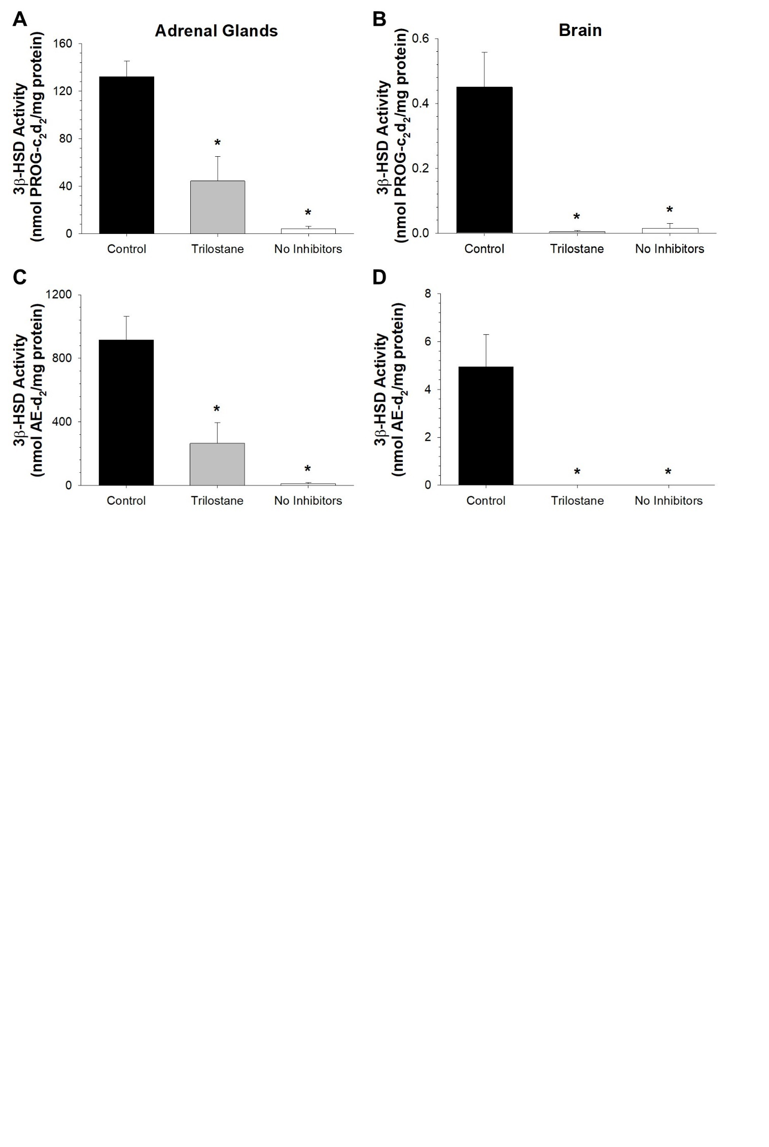

Figure S2. 3β-hydroxysteroid dehydrogenase/∆5-∆4 isomerase (3β-HSD) assay validation using pharmacological inhibitors of steroidogenic enzymes. Trilostane, a competitive inhibitor of 3β-HSD, significantly reduced progesterone (PROG; A, B) and androstenedione (AE) production (C, D) in the adrenal glands (A, C) and brain (B, D) relative to control samples. Similarly, control samples, which included abiraterone acetate and fadrozole hydrochloride (pharmacological inhibitors of cytochrome P450c17 and aromatase, respectively), had significantly higher 3β-HSD activity than samples containing no inhibitors, indicating that these compounds reduced the metabolism of formed PROG-c₂d₂ and AE-d₂. Bar heights represent means ± SEM (n = 3 per group), and “*” indicates a significant difference relative to control samples (p < 0.05; Welch’s t-tests).

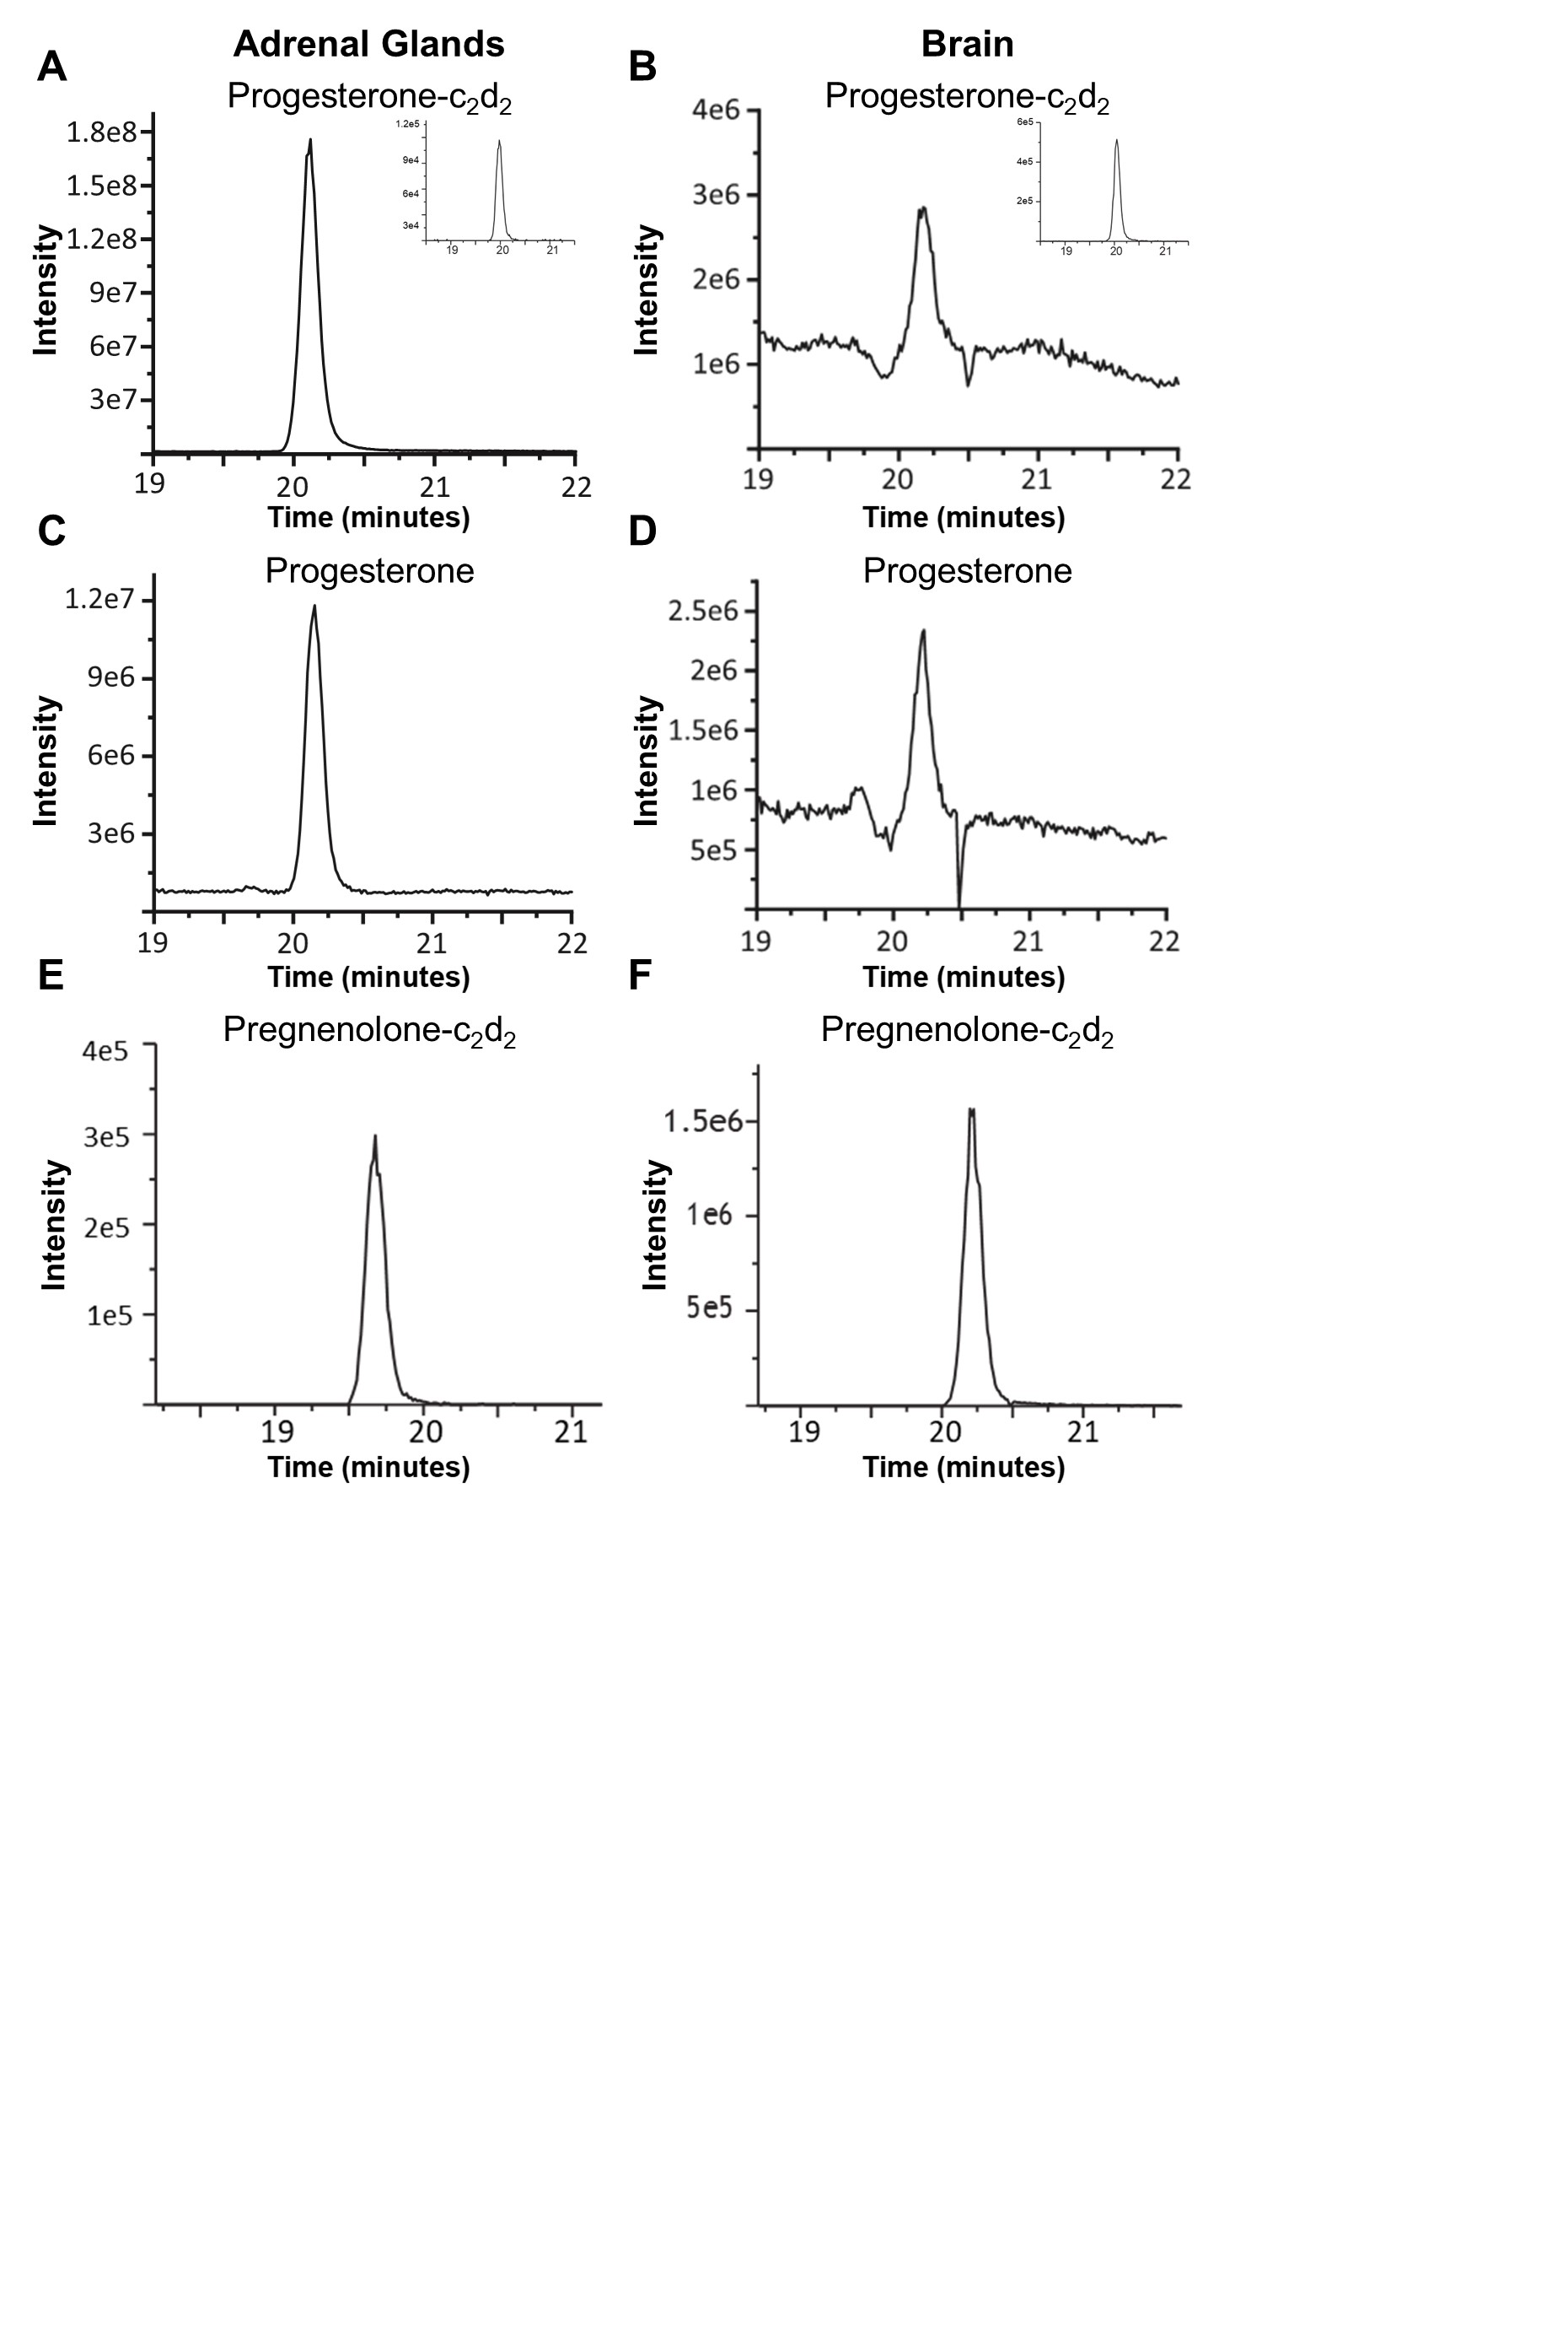

Figure S3. Quantification of progesterone production by 3β-hydroxysteroid dehydrogenase/∆5-∆4 isomerase in Siberian hamster adrenal and brain tissue via liquid chromatography-tandem mass spectrometry (LC-MS/MS). Representative extracted ion chromatographs of fragment ions from (A, B) progesterone-c₂d₂, (insets, A, B) progesterone-d₉, (C, D) progesterone, and (E, F) pregnenolone-c₂d₂ in the adrenal glands (A, C, E) and brain (B, D, F). MS/MS transitions for precursor and fragment ions are provided in table S2 (electronic supplementary material).
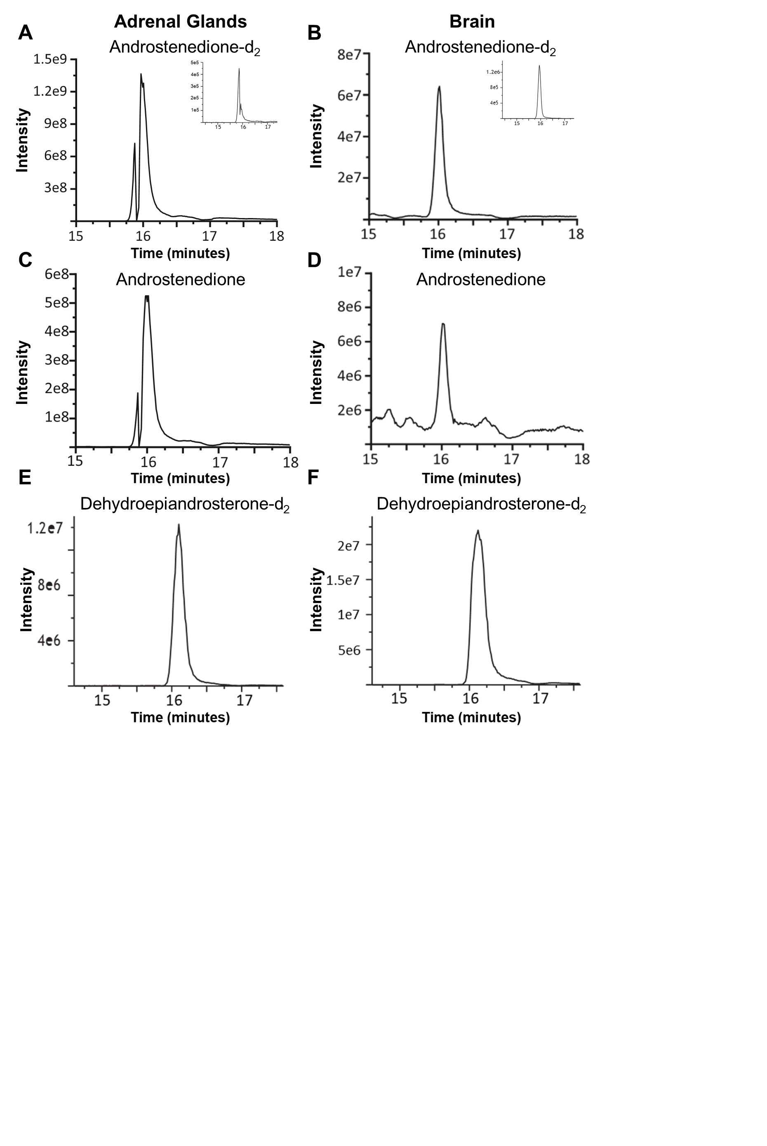
Figure S4. Quantification of androstenedione production by 3β-hydroxysteroid dehydrogenase/∆5-∆4 isomerase in Siberian hamster adrenal and brain tissue via liquid chromatography-tandem mass spectrometry (LC-MS/MS). Representative extracted ion chromatographs of fragment ions from (A, B) androstenedione-d₂, (insets, A, B) androstenedione-d₇, (C, D) androstenedione, and (E, F) dehydroepiandrosterone-d₂ in the adrenal glands (A, C, E) and brain (B, D, F). MS/MS transitions for precursor and fragment ions are provided in table S2 (electronic supplementary material).

REFERENCES
1. Brain P. What does individual housing mean to a mouse? Life Sci. 1975;16(2):187-200.
2. Brain P, Poole A. Some studies on use of "standard opponents" in intermale aggression testing in TT albino mice. Behaviour. 1974;50(1):100-10.
3. Munley KM, Deyoe JE, Ren CC, Demas GE. Melatonin mediates seasonal transitions in aggressive behavior and circulating androgen profiles in male Siberian hamsters. Horm Behav. 2020:104608.
4. Rendon NM, Rudolph LM, Sengelaub DR, Demas GE. The agonistic adrenal: melatonin elicits female aggression via regulation of adrenal androgens. Proc R Soc Lond, Ser B: Biol Sci. 2015;282(1819).
5. Williams B, Onsman A, Brown T. Exploratory factor analysis: a five-step guide for novices. Australas J Paramedicine. 2010;8(3).
6. Team RC. R: A language and environment for statistical computing. 4.1.2 ed. Vienna, Austria: R Foundation for Statistical Computing; 2021.
7. Revelle W. psych: procedures for personality and psychological research. 1.9.12 ed2019.
8. Dziuban CD, Shirkey EC. When is a correlation matrix appropriate for factor analysis? Some decision rules. Psychol Bull. 1974;81(6):358-61.
9. Kaiser HF. An index of factorial simplicity. Psychometrika. 1974;39(1):31-6.
10. Jolliffe IT, Cadima J. Principal component analysis: a review and recent developments. Philos Trans A Math Phys Eng Sci. 2016;374(2065):20150202.
11. Bennett BD, Yuan J, Kimball EH, Rabinowitz JD. Absolute quantitation of intracellular metabolite concentrations by an isotope ratio-based approach. Nat Protoc. 2008;3:1299-311.
12. Munley KM, Trinidad JC, Deyoe JE, Adaniya CH, Nowakowski AM, Ren CC, et al. Melatonin-dependent changes in neurosteroids are associated with increased aggression in a seasonally breeding rodent. J Neuroendocrinol. 2021;33(3):e12940.
13. Komsta L. outliers: tests for outliers. 0.14 ed2011.
14. Fachada N, Rodrigues J, Lopes VV, Martins RC, Rosa AC. micompr: An R package for multivariate independent comparison of observations. The R Journal. 2016;8(2):405-20.
15. Fox J, Weisberg S. An {R} Companion to Applied Regression. Thousand Oaks, CA: Sage; 2019.
16. Delignette-Muller ML, Dutang C. fitdistrplus: an R package for fitting distributions. J Stat Softw. 2015;64(4):1-34.
17. Magee L. R² measures based on Wald and likelihood ratio joint significance tests. Am Stat. 1990;44(3):250-3.
18. Nagelkerke NJD. A note on a general definition of the coefficient of determination. Biometrika. 1991;78(3):691-2.
19. Ferguson CJ. An effect size primer: a guide for clinicians and researchers. Prof Psychol Res Pr. 2009;40(5):532-8.
20. Oksanen J, Blanchet FG, Friendly M, Kindt R, Legendre P, McGlinn D, et al. vegan: community ecology package. 2.5-6 ed2019.
21. Hothorn T, Bretz F, Westfall P. Simultaneous inference in general parametric models. Biom J. 2008;50(3):346-63.
22. Dinno A. dunn.test: Dunn's test of multiple comparisons using rank sums. R package, 1.3.5 ed2017.
23. Long JA. jtools: analysis and presentation of social scientific data. R package, 2.1.0 ed2020.
24. Fox J, Friendly M, Monette G. heplots: visualizing tests in multivariate linear models. 1.3-9 ed2021.

