**SUPPLEMENTARY MATERIAL**

**Melatonin mediates seasonal transitions in aggressive behavior and circulating androgen profiles in male Siberian hamsters**

Kathleen M. Munley*, Jessica E. Deyoe, Clarissa C. Ren, & Gregory E. Demas

*Department of Biology and Center for the Integrative Study of Animal Behavior, Indiana University, Bloomington, IN 47405, USA*

**TABLES**

**Table S1.** Ethogram used to score aggressive and non-aggressive social behaviors in the resident-intruder paradigm (adapted from Jasnow et al., 2000; Scotti et al., 2015).

|  |  |
| --- | --- |
| **Behavior** | **Description** |
| **Attack**   * Number * Duration * Latency | Sideways or upright offensive posture that results in physical contact. Attack bouts are captured in duration and frequency and include biting, roll fighting, and pinning the subordinate. Attacks include events when there is distinct separation between the resident and intruder that is rapidly followed by another attack (≤ 3 seconds). Attacks exclude defensive behaviors, such as pushing, clawing, and boxing; and events where there is distinct separation between the resident and intruder that lasts for > 3 seconds prior to another attack. Latency is defined as the amount of time elapsed before the resident first attacks the intruder. |
| **Chase**   * Number * Duration | Rapid pursuit that leads to an attack. Upon contact, a chase is scored as an attack. |
| **Nose-to-Nose Investigation (NTN)**   * Frequency * Duration | Chemoinvestigation in which the resident and the intruder are face-to-face and their noses are in close proximity or touching. NTN also includes events where the resident’s nose is touching the top half (e.g., regions from the middle of the torso to the head) of the intruder’s body. |
| **Anogenital Investigation (AGI)**   * Frequency * Duration | Chemoinvestigation in which the resident investigates the anus or genital area of the intruder. AGI also includes events where the resident’s nose is touching the bottom half (e.g., regions from the middle of the torso to the hindlimbs) of the intruder’s body. |
| **Scent Marking (SM)**   * Frequency * Duration | Ventral gland is rubbed along the surface of bedding material and secretions are deposited. |
| **Grooming (GR)**   * Frequency * Duration | Self-grooming events of the face, head, or flanks. |

**Table S2**. Principal component loading values and eigenvalues for variables that were used to examine differences in aggressive behavior and circulating androgen profiles across seasonal phenotypes after 9 weeks of treatment.

|  |  |  |
| --- | --- | --- |
| **Variables** | **PC1** | **PC3** |
| Number of Attacks | **0.486** | 0.237 |
| Attack Duration | **0.318** | **0.339** |
| Number of Chases | **0.487** | -0.032 |
| Chase Duration | **0.479** | -0.050 |
| Attack Latency | -0.172 | 0.083 |
| Basal DHEA | 0.024 | **-0.345** |
| ∆DHEA | -0.121 | **0.701** |
| Basal T | -0.058 | **0.436** |
| ∆T | **-0.384** | 0.131 |
| **Eigenvalues** | 2.674 | 1.350 |

Loading values for principal components 1 and 3 (PC1 and PC3, respectively) are shown for the PCA in Figure 4, in which aggression and circulating androgen profiles were compared across seasonal phenotypes. The PCA consisted of both aggression variables (number of attacks, attack duration, number of chases, chase duration, latency to first attack) and serum androgen concentrations [basal dehydroepiandrosterone (DHEA), ∆DHEA, basal testosterone (T), ∆T] in long day (LD) hamsters, LD hamsters administered timed melatonin injections (LD-M), and short day (SD) hamsters following 9 weeks of treatment. Data were used from 7 LD hamsters, 11 LD-M hamsters, and 15 SD hamsters. PC1 accounted for 29.7% of the total variance, whereas PC3 accounted for 15.0% of the total variance (cumulative variance explained = 44.7%). Bold values indicate variables that loaded strongly (less than -0.3 or greater than 0.3) onto a given PC.

**FIGURES**

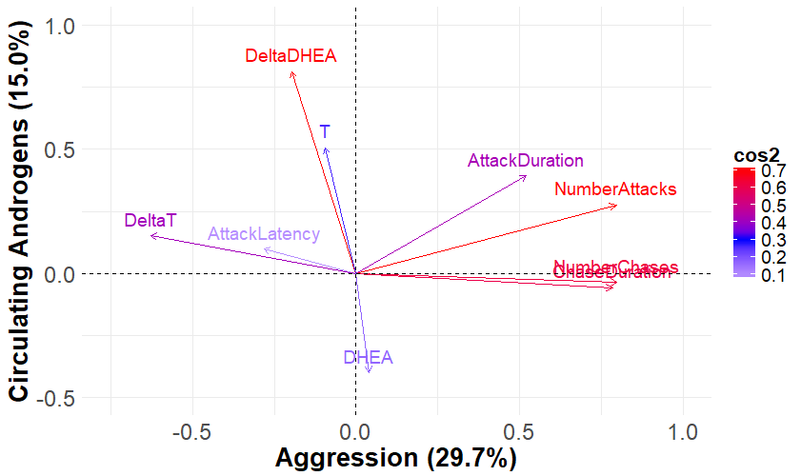

**Figure S1.** Variables factor map of the principal components (PCs) used to visualize differences in aggressive behavior and circulating androgen profiles across seasonal phenotypes following 9 weeks of treatment (shown in Figure 4). Positively correlated variables are grouped together on the same side of the origin, whereas negatively correlated variables are grouped on opposite sides of the origin. Cos2 values represent the squared cosine of a given variable and reflect the quality of representation of this variable on the factor map. Cos2 values are represented on a gradient color scale, in which high cos2 values are in warm colors and mid and low cos2 values are in cool colors. PC1 (“Aggression”) accounted for 29.7% of the total variance and was strongly loaded by number of attacks (“NumberAttacks”), attack duration (“AttackDuration”), number of chases (“NumberChases”), chase duration (“ChaseDuration”), and ∆T (“DeltaT”). PC3 (“Circulating Androgens”) accounted for 15.0% of the total variance and was strongly loaded by basal DHEA (“DHEA”), basal T (“T), ∆DHEA (“DeltaDHEA”), and attack duration.

**REFERENCES**

Jasnow, A.M., Huhman, K.L., Bartness, T.J., Demas, G.E., 2000. Short-day increases in aggression are inversely related to circulating testosterone concentrations in male Siberian hamsters (*Phodopus sungorus*). Hormones and Behavior 38, 102-110.

Scotti, M.A., Rendon, N.M., Greives, T.J., Romeo, R.D., Demas, G.E., 2015. Short-day aggression is independent of changes in cortisol or glucocorticoid receptors in male Siberian hamsters (*Phodopus sungorus*). Journal of Experimental Zoology Part A: Ecological Genetics and Physiology 323, 331-341.